6-26 JULY 2017

#SSYLF

#NxGenSouthSudan

The #NxGenSouthSudan campaign is an initiative of South Sudan Young Leaders Forum (SSYLF) that plans to educate and mobilise South Sudanese population and the IGAD region to end the conflict in the country with the utmost urgency. The campaign articulates the views of the SSYLF, which were endorsed during a two-day meeting in Nairobi in 9-10 January 2017. These resolutions have been synthesised into propositions covering political strategy out of the conflict and the technical policies for reconstituting the state from the perspective of the youth – the overwhelming majority of South Sudan’s population (75 per cent of people are under the age of 30 years). These technical policies are articulated in five policy notes as follows: Economic Reform and Recovery, Rethinking Approaches to Governance, Addressing Famine and Humanitarian Crisis, Envisioning Security Sector Reform, and National Dialogue and Peace-building. The notes also tackle the critical question of how such overreaching reforms can be sequenced and effectively executed. The policy notes aim to provoke an informed debate so that all the people of South Sudan are well equipped to effectively participate in the political transformation taking shape in their country and that the regional partners are well informed to better help them.

The SSYLF is a forum of over 70 South Sudanese young leaders from across South Sudan and representing 20 different ethnic groups in South Sudan, and from across the Diaspora in Uganda, Kenya, Ethiopia, Egypt, Australia, Canada, United Kingdom, and the United States of America. The SSYLF members are at the forefront of peace building, reconciliation and state building in South Sudan.

The individuals listed below were selected from the larger pool of SSYLF to represent the group in the regional consultations. They include leading academics, church leaders, policy experts, youth leaders, and the civil society leaders at the forefront of change in the country. The regional consultations will involve meetings with senior policy-makers in the region and the South Sudanese Diaspora. The SSYLF delegation will articulate the message of the youth under the theme “#NxGenSouthSudan” – a call to action for the next generation of South Sudan.

THE SOUTH SUDAN YOUNG LEADERS DELEGATION FOR REGIONAL CONSULTATIONS

Peter Biar Ajak is the Founder and the CEO of South Sudan Wrestling Entertainment, a nonprofit organisation that uses the indigenous sport of wrestling to promote peace among South Sudan’s tribes. He is a Senior Advisor at the International Growth Centre (IGC) on South Sudan & Fragile States and a former Co-Country Director in South Sudan. Peter was previously South Sudan’s World Bank Economist, co-chairing the Economic Development Pillar during the drafting of the South Sudan Development Plan (SSDP) and the Vision 2040. Peter was also previously the Coordinator of Policy and Strategy in the Office of the Minister of National Security in the Office of the President, assisting with the drafting of the South Sudan’s White Paper on Intelligence & National Security, the National Security Act, and the National Security Policy and Strategy. Peter is currently a member of the SPLM Economic Taskforce, the ruling party’s highest economic policymaking body. His work has appeared in a number of reputable international media sources, including New York Times, Foreign Policy, BBC, Al Jazeera, and The Economist. A former “lost boy” of Sudan, Peter holds a BA in Economics from LaSalle University, a master’s of public administration in international development (MPA/ID) from John F. Kennedy School of Government, Harvard University, and he is finalising a PhD in Politics and International Studies at Trinity College, University of Cambridge.
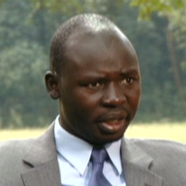

Riya William Yuyada is the Co-Founder of Play for Peace South Sudan and the Founder of Crown The Woman-South Sudan, a women founded and led grassroots organisation that aims at addressing women’s issues to foster a future with zero tolerance for inequality, inequity, injustice and any other community vices that affect women and children. Riya is passionate about peace, children, youth and women’s rights. She previously worked with Mundri Relief and Development Association as a Civic Education Officer where she encouraged people to adopt peaceful co-existence in Internally Displaced Persons (IDPs) camps, and distributed food and helped people grow their own. Following the outbreak o the on-going civil war, Riya realised that one of the ways to reach children was through empowering their mothers and girls socially, politically and economically. This led to the establishment of Crown The Woman-South Sudan. Riya is an alumna of the 2017 Department of State’s International Visitor Leadership program (IVLP) on education and women’s activism, the 2016 Young African Leadership Program, the Feminist Leadership, Movement Building and Rights Institute East Africa and the 2015 Nobel Women’s Initiative’s Sister-to-Sister Mentorship program. Riya holds a bachelor’s degree in Development Economics from Makerere University.
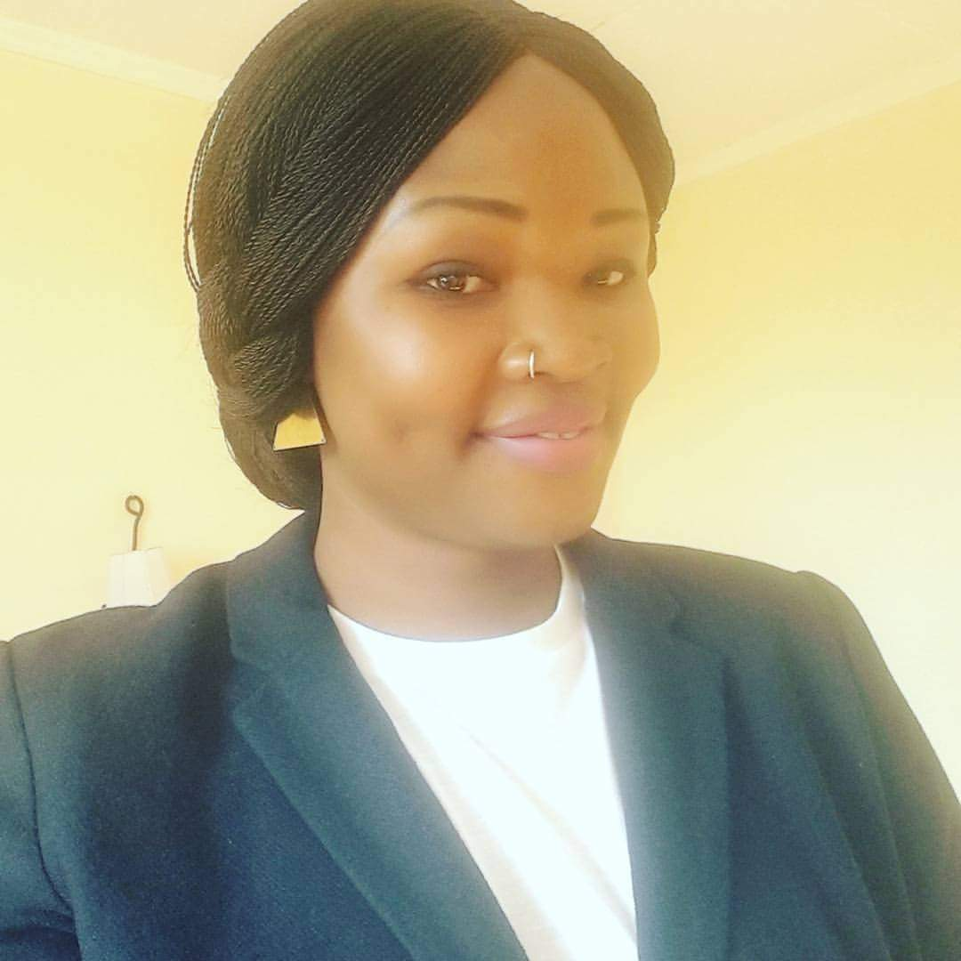

Deng Bol Aruai Bol is a humanitarian, motivational speaker, business and nonprofit consultant, media and ICT specialist and entrepreneur. Deng has work record that spans over 20 years. In the U.S., he worked for Vista Peak Community Health Centers specifically for the Colorado Indigent Care Program (CICP) and later worked for the 5-Star-5-Diamond, Broadmoor Hotel in Colorado Springs, Colorado. Before going to the United States, he worked for many international organisations including UNHCR, International Rescue Committee (IRC), Lutheran World Federation and Save the Children International (SCI). Deng is a University graduate with a bachelor’s degree and several professional certificates in technology, nonprofit and business. He has attended and completed many workshops and special trainings in the U.S and South Sudan. Deng is the founder of the Deng Foundation, a national peace and development public foundation that supports grassroots organisations. His work with the Deng Foundation on inclusive democracy was featured on CNN International and BBC Focus on Africa and many other national and international news media. Deng is a founding member of the Rotary Club of Juba and served later as Club President 2010/2011. Deng for many years has been involved in disability and civil rights advocacy and has been an active fundraiser for organisations. A member of the SPLM/A Red Army since 1987, he has for the last five years served as Chairman of the Board of Trustees of the Red Army Foundation, a national patriotic veterans organisation. He was recently appointed to the National Dialogue Steering Committee. He resides in South Sudan and the Kingdom of Thailand.
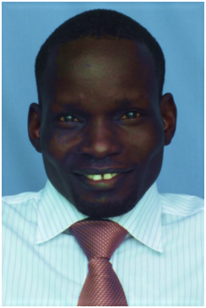

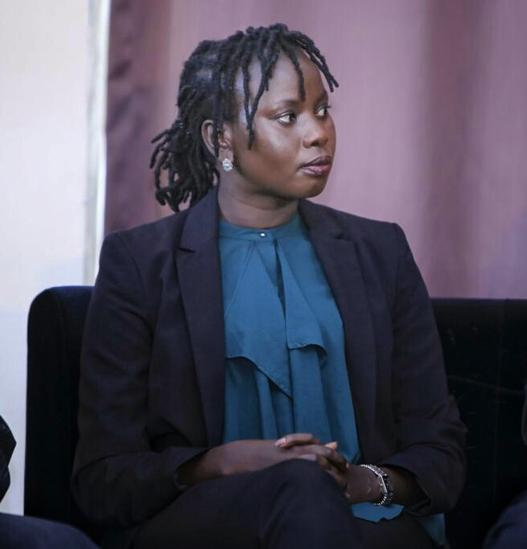
Nyagoah Tut Pur is the Campaigner on Sudan and South Sudan at Amnesty International. She researches and documents human rights violations and abuses committed in the conflicts in both countries. She equally designs and spearheads campaigns on both countries in partnership with national civil society organisations. Her research and commentaries have appeared in a number of media outlets, including Al Jazeera, BBC, and TVC Africa. Prior to joining Amnesty International, Nyagoah was the Advocacy Officer at the South Sudan Law Society, a civil society organisation based in South Sudan that works on access to justice, governance, and rule of law. Nyagoah holds a Bachelor of Laws (Hons) from the University of Nairobi and will start a Master of Laws (LLM) at Harvard Law School (HLS) in September 2017.

Emmily Nasungba Modi Koiti is a medic at Juba Teaching Hospital, South Sudan. She holds an MBBS from the University of Juba. As a passionate civic rights activist, she also volunteers as an Assistant Program Officer at the South Sudan Democratic Engagement Monitoring and Observation Program (SSuDEMOP), a lobby and an advocacy Civil Society Organisation that mobilises and empowers South Sudan’s citizens to effectively participate in the on-going process political process in their country. Emmily represents the youth in the Joint Monitoring and Evaluation Commission (JMEC) that oversees the implementation of the Agreement on the Resolution of Conflict in the Republic of South Sudan (ARCISS). She also serves on the board of Crown the Woman –South Sudan (CREW), a women-led organisation that focuses on elevating the status of women in the country. She is also an alumna of the Study of United States Institutes (SUSI) Program, 2012.
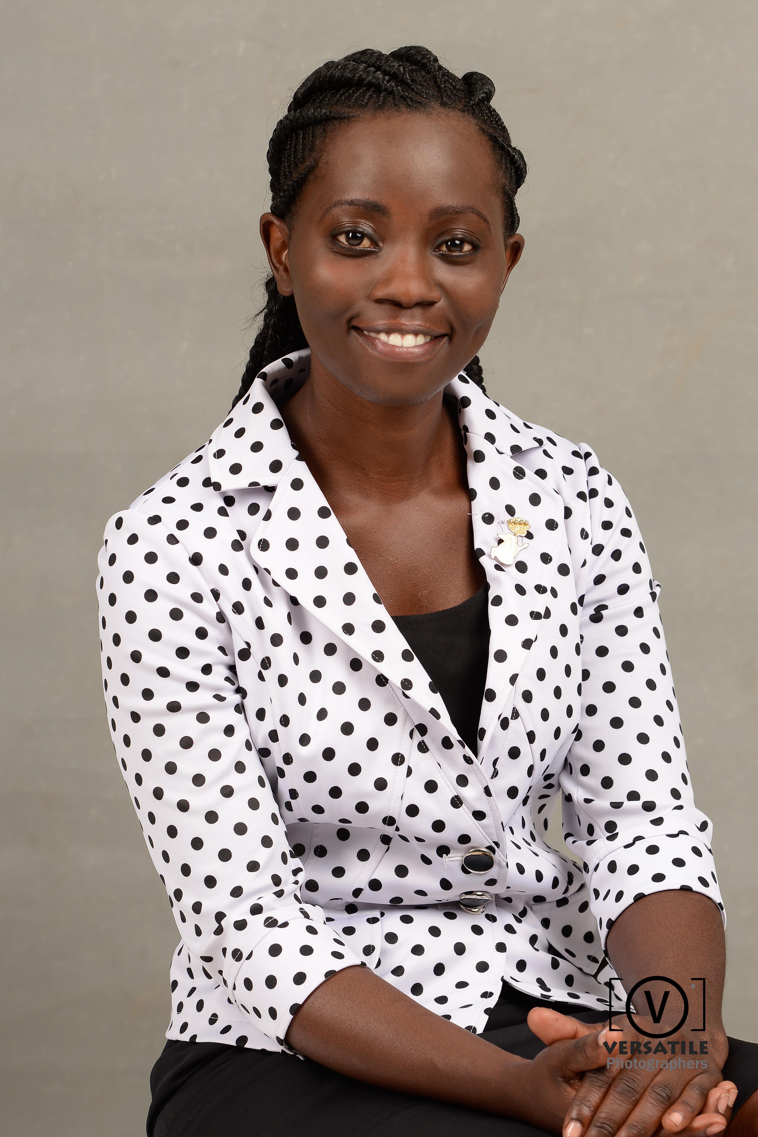

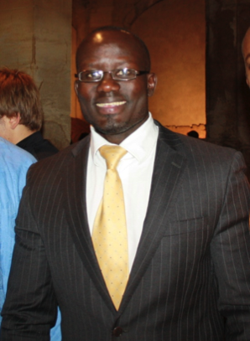

Mario Konyen Joseph, as he formally goes, or otherwise Nakuwa Jnr amongst his contemporaries, holds a Master’s degree in Development Economics (UEA, 2004, UK) and a BA (Hon.) in Economics with Development Studies (UCLan, 2003, UK). He is also an alumnus of the United World Colleges movement, having attended the UWC Mahindra College (2000, India) where he attained the International Baccalaureate (IB) Diploma. He received short-term trainings in Lobbying & Advocacy, Project Budgeting, Monitoring and Evaluation for Accountability, Leadership & Transparency in Africa, Effective Planning and Management of Programmes & Funding Proposals and Negotiating with Funding Agencies. He has over 10 years of post-master’s practical & technical experience in project/programme management, project/funding proposal drafting, management of donor & institutional relations, economic/development policy research & capacity building for post-conflict situations, the role of private sector and social entrepreneurship in less-developed economies.

Beny Gideon Mabor Manhom is South Sudan’s Human Rights Commissioner, a lawyer, and a human rights defender. He holds an LLB with honors from the University of Juba, and a post Graduate Diploma in Legal Practice from the Institute of Legal Practice and Development (ILPD), Rwanda. Beny is an advocate of High Courts of South Sudan. He has represented South Sudan in international forums in recent years and was a participant in the negotiation of the Agreement on the Resolution of Conflict in the Republic of South Sudan (ARCISS). He is a Research Fellow at the Africa Centre for Justice and Peace Studies in collaboration with the East and Horn of African Human Rights Defenders Network. Beny Gideon is a member of various regional and international legal bodies. His areas of research are politics, governance, human rights and social accountability.
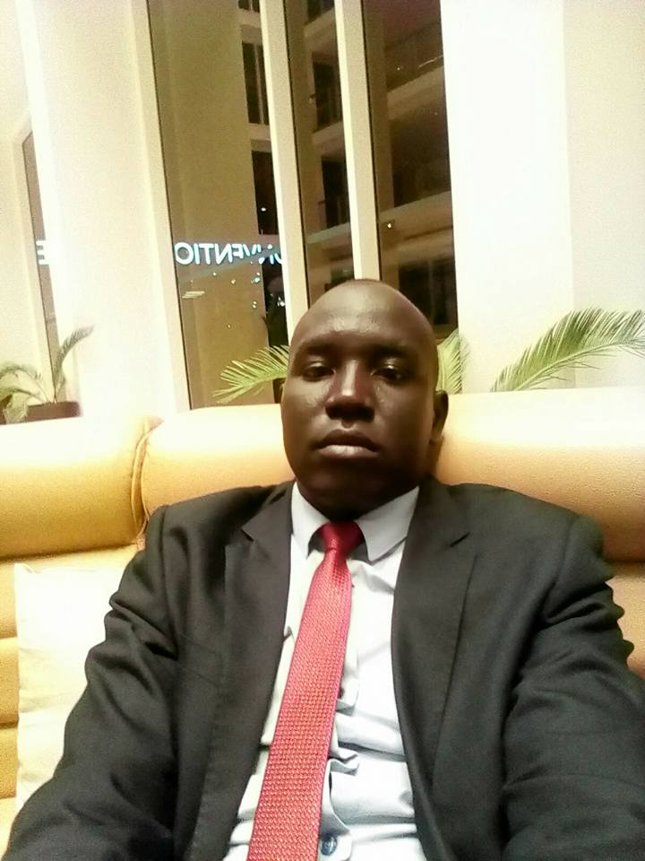

Adhieu Majok, or Sieta as she is popularly known, is a Masters graduate with a Micriobiology background, a business manager and a South Sudan analyst and journalist who has been featured on the BBC, Al-Jazeera, TVC Africa and Dutch newspaper, Trouw. Since 2013, she monitored hate speech among South Sudanese on social media. This resulted in her co-headlining at the #DefyHateNow conference in Berlin in July 2014. In 2015, Sieta took a hiatus from South Sudan's first entertainment news site, Talk of Juba to pursue her Masters. After completing it, she joined TEDxEuston (London) Digital Communications Team as a Digital Communications Assistant. Sieta has covered the war in South Sudan since 2013 through different South Sudan based media outlets and also on social media.

Manasseh Ruot Mathiang is a peace activist, an award-winning musician, and a marketing executive. He is the coordinator of Anataban Arts Initiative, a youth movement that uses arts to engender peace in South Sudan. He is also the former South Sudan social media correspondent with the #defyhatenow campaign and a former representative of South Sudan to the International Conference on Peaceful Speech. Manasseh was a delegate of the Coalition of Young Leaders of South Sudan (CYLOSS) to the Addis Ababa peace process during the early periods of the 2013 civil war. He is also the founder of the Marketing Solutions Co. ltd, an agency that offers various services within the business fraternity. He is a Young African Leaders Initiative alumnus, 2012, and was a panelist at the Africa Growth and Opportunity Act Summit (AGOA), hosted in Washington in 2012
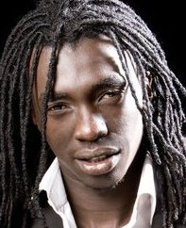

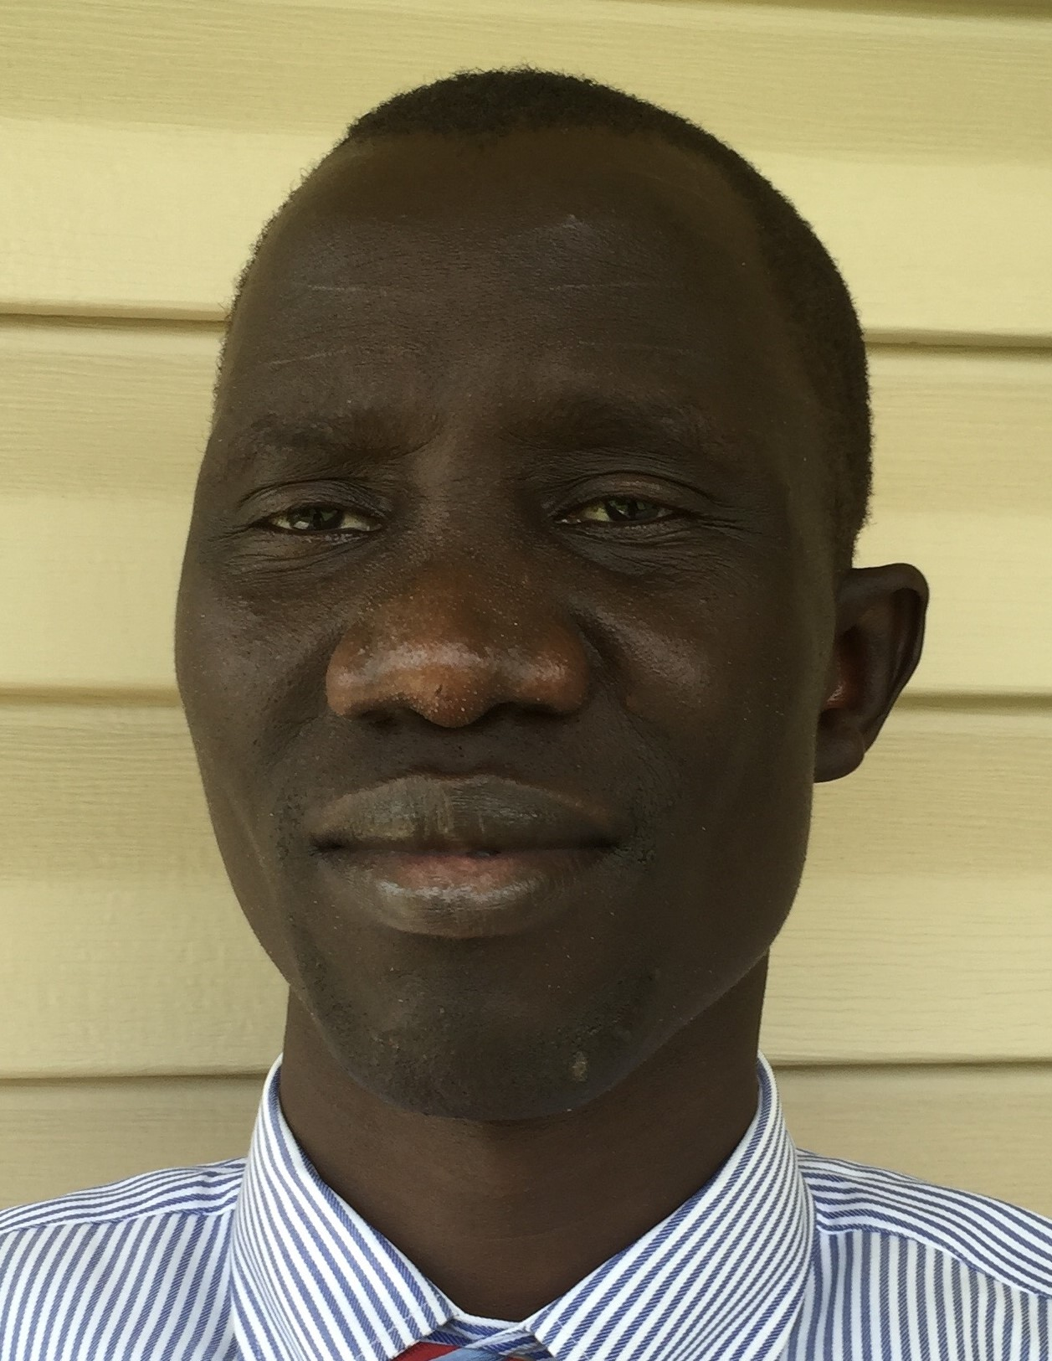

Augustino Ting Morter Mayai is the Director of Research at the Sudd Institute and an Assistant Professor at the University of Juba’s School of Public Service. He holds a PhD in Sociology, with concentrations on demography and development from the University of Wisconsin-Madison. He currently studies how state effectiveness affects child health outcomes in South Sudan and Ethiopia. Dr. Mayai has written extensively on South Sudan’s current affairs.

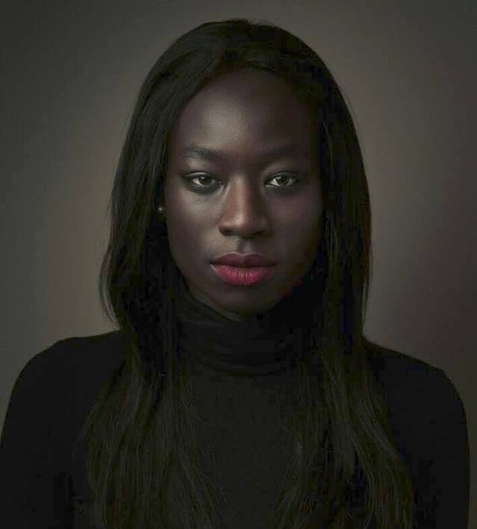

Agyedho Adwok Nyaba is a communication specialist with over five years of experience in strategic communications, aid and donor coordination, civil society engagement, advocacy, conflict mediation and negotiation, migration, private sector development, and gender. Prior to joining UNHabitat, Ms Nyaba worked with IOM (HQs in Geneva) IFC-WorldBank Group, Joint Donor Team, GoSS, UNESCO, EFE. She holds an MA in Peace, Conflict and Development Studies from Universitat de Jaume I and a BA in Journalism from the United States International University.

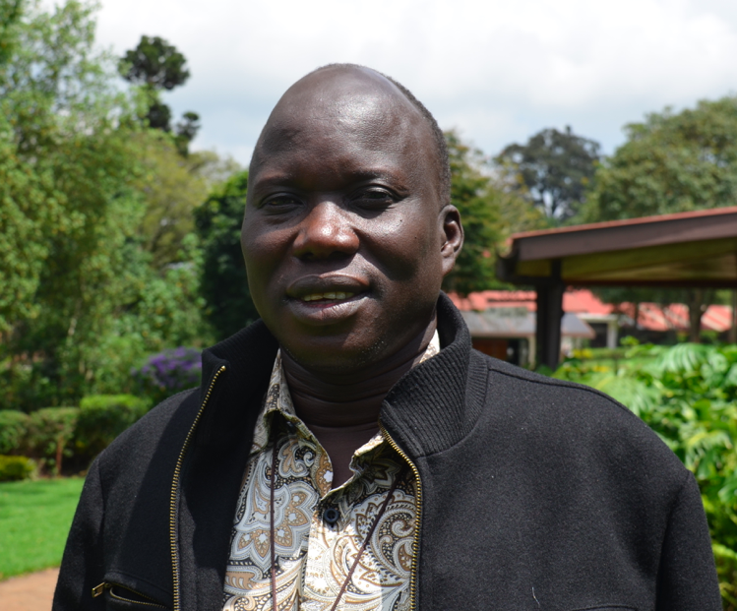

Rt. Rev. Abraham Yel Nhial Yel is the first Bishop of the Diocese of Aweil and has served since 2010. He joined Jol Wo Liec, the Ministry of Youth as a Sunday School and Youth teacher in Kakuma Refugee Camp in 1994. He was commissioned as an Evangelist in 1995, Ordained to the Holy Order of Deacons in 2000, and ordained in the Holy Order of Priests in July 2009. Bishop Abraham Yel Nhial holds a Master’s of Divinity from Trinity School of Ministry. He currently studies at St. Paul's University, Limuru, Kenya and will graduate with a Master’s of Development, Peace Building, and Conflict Transformation in 2018.

Nyuon Susan Sebit William is a lawyer and advocate who is passionate about the rule of law, access to justice, good governance and human rights, especially as it concerns women, children and other vulnerable groups. Susan graduated from the University of Juba’s College of Law with an LLB in 2013. She is a licensed advocate in the Republic of South Sudan. She was a fellow of the US Department of State’s Studies of the US institute (SUSI), where she was awarded a certificate of Leadership in Gender studies. Susan is the Executive Director of National Alliance for Women Lawyers, South Sudan.

#SSYLF

#NxGenSouthSudan

